FAA Aviation Weather Research Program
Model Development and Enhancement Product Development Team

Deliverable 10.5.8.E3: Status report on aerosol parameterization in the WRF model
By Trude Eidhammer, Greg Thompson, and Roy Rasmussen NCAR

Date: 30 July 2010
1. Introduction

The formation of clouds in the atmosphere is dependent on several factors, such as temperature, relative humidity, vapor pressure, and aerosols. Without aerosols, clouds would not form in the atmosphere. Temporal and spatial variations in aerosol concentration and composition impact cloud droplet and ice crystal formation, which further impacts the phase and lifetime of clouds, as well as the amount of precipitation. Nearly all of the regional and global scale models ignore this temporal and spatial variation due to complexities in observing and modeling the explicit creation of droplets and ice as well as computer limitations. However, their role is paramount in the creation of clouds and recent advances in computing now permit their direct inclusion in the most advanced atmospheric models.

This report is intended to summarize the recent efforts by the FAA’s AWRP research teams to include aerosols explicitly into the Thompson et al. (2008) bulk microphysics scheme when creating cloud droplets and ice crystals. The current effort is a first step and we expect that various improvements will be included in future years to produce model results that match observations and result in better forecasts, specifically for the In-Flight Icing program since cloud phase impacts the likelihood of icing more than any other atmospheric variable. There are a number of steps and processes required to include aerosols into a cloud physics scheme and each step is briefly summarized in the subsections below. Examples and preliminary tests of specific processes are also documented that show initial success as well as areas for future improvements.

2. Aerosol global climatology

To model the initiation of droplets and ice crystals, the aerosol size distribution and composition should be known. For droplet formation, many different aerosol types can serve as cloud condensation nuclei (CCN), but sulfates and sea salts are considered the most dominant and effective CCN. For ice crystal formation, dust, especially particles larger than 0.5 μm, is believed to play the most dominant role as ice nuclei (IN). Other aerosol candidates for either droplets or ice crystals including organic and black carbon (soot) and various trace metals or minerals are all neglected at this time, as they are believed to play a miniscule role in typical cloud formation.

To generate boundary and initial conditions for WRF model runs, we obtained a modeled global climatology aerosol dataset. This dataset was generated by the Goddard Chemistry Aerosol Radiation and Transport (GOCART) model (Chin et al., 2009) and provided mass concentration of sulfate, salts, organics, and dust aerosols for each month from 2000 to 2007. To simplify, we averaged each month from the seven years of simulation. The global climatology is relatively coarse by comparison to mesoscale models like WRF since it used a 1.0°x1.5° grid and thirty vertical levels, but it is extremely useful for preliminary testing as it contains the most fundamental spatial and temporal variations. A special software program called “mozbc” was heavily leveraged and adapted to prepare/manipulate the aerosol data for use in our WRF simulations. In the future, direct variables from the WRF-Chem model could be used instead of the climatology data to capture more realistic events, particularly aerosol emissions from the surface.

The input GOCART sulfate and salts mass concentrations for various size ranges are combined and converted to number concentration for use in droplet formation. This is one of a number of simplifications that was picked to reduce computational burden and could be improved in the future to incorporate more than one source of CCN. The number distribution of Chin et al. (2009) was assumed for sulfates and sea salt when converting mass concentration to number.

The dust aerosol is used for ice crystal formation and was provided by GOCART in mass concentration for five size ranges. Also here, the mass is converted to number concentration based on the assumed size distributions in Chin et al. (2009), however, only the number concentration of dust particles larger than 0.5 μm is calculated, since recent research indicates that this information serves as a proxy for determining ice nucleation (DeMott et al., 2010). Figure 1 shows an example of the initial low altitude dust concentration for a North American simulation for two different months, April and August. The variation in dust concentration between the months is clearly evident.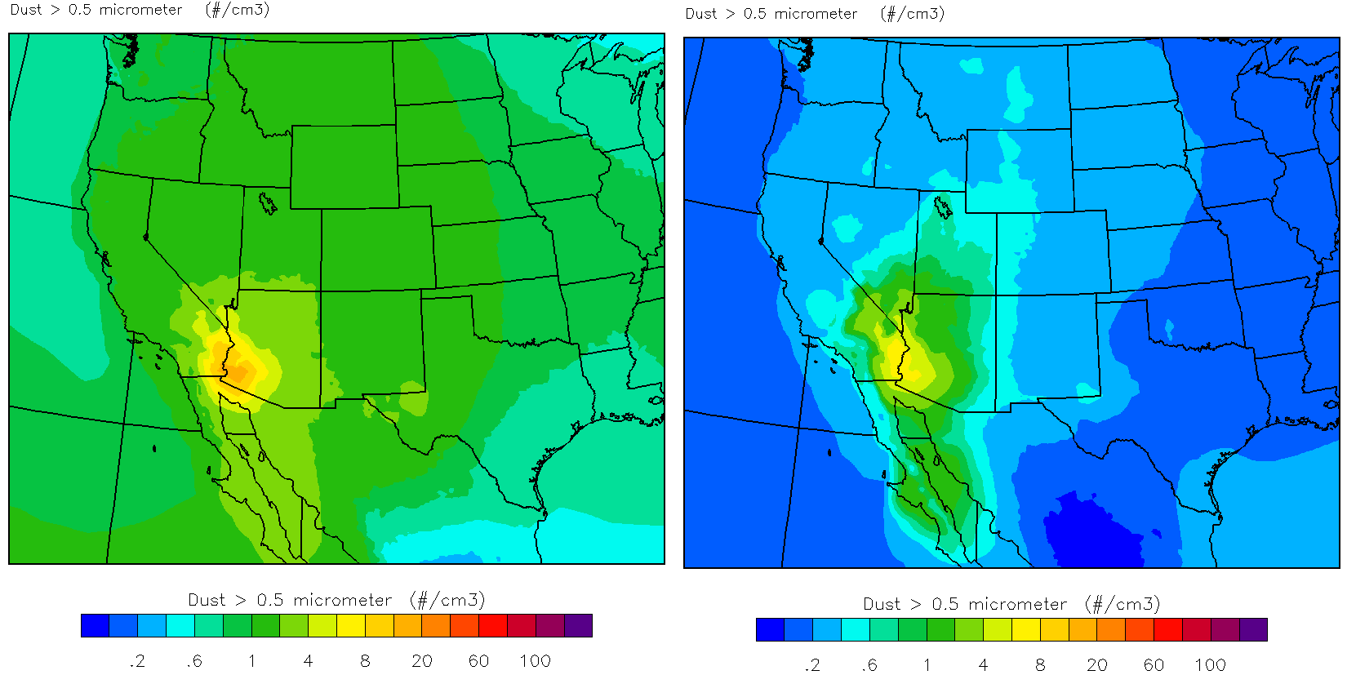
Fig. 1 Example of lowest model level dust concentration for month of April (left) and August (right)

3. Aerosols as cloud condensation nuclei

With the inclusion of aerosol data, the next step is to create cloud droplets on these particles rather than the previous assumption that a constant number of droplets existed everywhere and all the time. An additional computation burden arises because the number of unactivated aerosols as well as the number of cloud droplets is added to the list of variables explicitly carried by WRF. Also, new code additions to treat the removal of cloud droplet number by growth to rain or collection by ice species or water freezing into ice increases the complexity as well as the time required to perform model simulations. However, without such additions, the model wasn’t entirely capable of replicating both clean maritime airmasses as well as urban or polluted conditions typical in continental regions simultaneously within a single simulation.

The additional code needed for depleting cloud droplet number by the various processes are all internally consistent with the previously existing methods to deplete the mass, when, for example, cloud droplets freeze into ice crystals or get collected by falling snow. However, it is far more complex to parameterize the initial creation of cloud droplets onto aerosol particles. There are many textbook chapters devoted to this topic alone and the most sophisticated models typically use up to a hundred or more variables to achieve this goal in a proven way. Over the last three decades, numerous parameterizations of the droplet activation process have been attempted and we rely on one of the most widely accepted methods: that is to utilize results produced by a much more sophisticated parcel model whose tabulated data are stored in a pre-computed look-up table. Specifically, we used the parcel model of Feingold and Heymsfield (1992) with changes described in Eidhammer et al. (2009). The parcel model was run hundreds of times with various input settings for aerosol concentration, updraft velocity, temperature, hygroscopicity (a measure of how readily certain aerosols absorb water vapor to become droplets), and aerosol mean size (Ward et al., 2010).

During the WRF simulation, when saturated conditions are detected, the tabulated parcel model results are consulted using WRF’s predictions for aerosol concentration, updraft velocity, and temperature plus an assumed aerosol mean size and hygroscopicity to retrieve a fraction of the input aerosol concentration that will become the newly activated cloud droplets. Then, the activated number become droplets and is removed from the aerosol population. In its current implementation, we assumed a relatively small aerosol mean size of 0.02 μm, which is considered typical for ammonium sulfate (one of the biggest sources of CCN) and hygroscopicity of 0.4, which is rather typical of a mixture of many aerosols found in many regions around the world. A future version of the scheme may provide means to vary these two parameters depending on other variables, especially those available from WRF-Chem.

Additional considerations for the production and depletion of aerosols include source emissions from the surface, both natural and manmade, collection of aerosols by falling precipitation, and release of aerosols as water droplets evaporate or ice sublimates. At this early stage, some simplifications were required that warrant future investigation and testing as time permits. In the case of source emissions, the matter is extremely complex and requires many additional variables and more complete chemical modeling so our simplification enforces a constant amount of aerosols consistent with the input data at the lowest model level. In the case of aerosols scavenged by falling precipitation, we currently neglect this process but expect to include a mechanism in a subsequent version. Lastly for evaporation of water drops in order to release aerosols back into the population of available aerosols, we release one particle for one droplet, even though the evaporated droplet may have contained many more aerosols in the case where it grew by collisions with other cloud or rain drops.

4. Processes that affect dust concentration

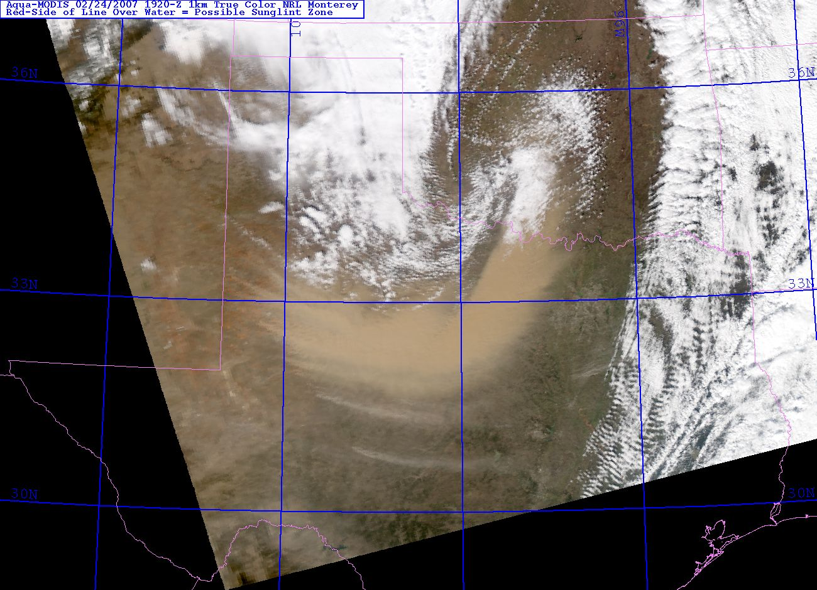
Dust is removed from the atmosphere by three mechanisms: it falls to the surface due to gravitational settling and Brownian diffusion (dry deposition), it serves as an ice nuclei and becomes embedded into precipitation particles (snow), or it can be captured by water drops or ice crystals that fall from higher levels (wet deposition). The primary cause of dust entering the atmosphere is when strong winds lift the particles off a dry and relatively barren earth’s surface. All of these processes have been included in the model at this time. Any secondary sources of dust from volcanic eruptions and man-made emissions like factories or cars driving on dusty roads is currently neglected and considered unimportant at this time. Most of the dust observed far above the earth’s surface can be traced back to major desert regions including the Sahara, Gobi, or U.S. southwest caused by relatively large scale storms lifting massive quantities of dust high in the atmosphere that clearly show up on satellite images (see Fig. 2).
Fig. 2 Example of a large-scale dust storm in eastern NM and west TX is clearly evident in this satellite image.

In our first version of the aerosol scheme, we continued a relatively standard practice for the removal of dust by dry and wet deposition. These processes are treated in the WRF-Chem MOSAIC model, which was followed in our implementation with simplifications related to our usage of a single number concentration rather than multiple size bins. The ejection of dust from nearly bare and dry soil is also adapted directly from the WRF-Chem MOSAIC model. The remaining dust process is of primary importance in the formation of clouds and water phase – acting as ice nuclei. This is treated following the parameterization of DeMott et al. (2010) for heterogeneous nucleation of ice crystals and by following Koop et al. (2000) for homogeneous freezing of deliquesced aerosols.

All of these processes have inherent assumptions and specific elements will require additional research to determine optimal settings for use in a mesoscale model. One example is the ejection of dust from the ground. In our preliminary tests, we see what we believe is excessive dust being lifted off the ground from an island off the coast of Baja California and in southeastern CA. Furthermore, from collaborations with other scientists working more directly on dust emission, the number of vegetation and soil categories available in standard WRF oversimplifies the true earth’s surface and refinements in the categories may be possible in order to improve dust emission from the surface.

5. Preliminary model results

The addition of the primary aerosol codes was performed in two separate and major steps: the cloud droplet activation on sulfates and salt; and the nucleation of ice on dust. These codes are not yet unified into a single source code for complete testing, but this task should be completed by end of fiscal year 2010. Therefore, this section contains results from the separate code additions and will be discussed in the same order as mentioned in the previous section.

5.1 CCN activation evaluation

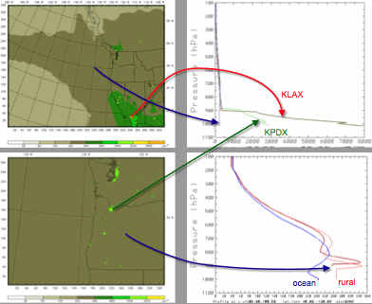
A preliminary WRF test case was created to exercise the new droplet activation from aerosols. A case study from the IMPROVE-II field program, which has been studied extensively in the past, provided a good baseline for these tests. A total of four experiments were conducted: Experiment 1 used the original code with constant droplet number set very low to mimic clean maritime air whereas Experiment 2 used the same code but with much higher droplet number that would be more typical of mid-continental air. These tests should capture the absolute extents of the experiments to follow with variable aerosols and cloud droplets. Experiment 3 used the variable aerosols from the climatology input, which resulted in relatively low aerosol concentrations since the study area focused on the Pacific Northwest U.S. Experiment 4 used the same code as Exp3 but the aerosols were intentionally increased by nearly fifty times to mimic excessively polluted air.

WRF was configured with three grids with horizontal spacing of 9, 3, and 1 km and 71 vertical levels and simulations were conducted for 36 hours beginning at 0000 UTC 13 Dec 2001. Since the input climatology data is extremely coarse resolution compared to the WRF grids in this case, the WRF land points designated as urban were altered to increase the aerosol concentration by a factor of ten that decreased exponentially with height in the lowest 1 km. This alteration provided a fake emission of aerosols since the lowest model level aerosols were also held constant during the simulation. An example of the starting aerosol concentration on grids 1 and 2 along with a few example vertical profiles are shown in Fig. 3. Note the extreme pollution at Los Angeles (KLAX) and Portland (KPDX).
Fig. 3 Initial aerosols on grids 1 and 2 (left panels) and select vertical profiles (right panels).
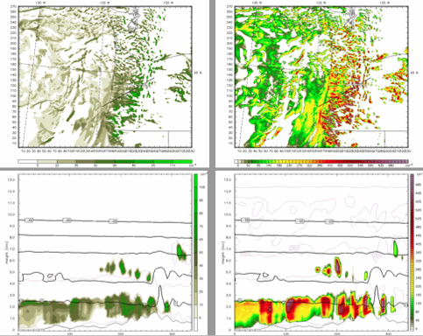
Fig. 4 Cloud droplet number concentration approximately 1 km AGL and along a cross section from Experiment 3 (left panels) and Experiment 4 (right panels).
When changing the available aerosols as dramatically as mentioned for Exp4, there should be an obvious impact to the cloud droplet concentration with far lower droplet numbers in Exp3 than in Exp4. This is verified in Fig. 4 that shows a plan view at approximately 1 km above ground level as well as a cross-section taken from southwest to northeast over the Oregon Coastal Range and Cascade mountains. The panels on the left are results from Exp3 and show cloud droplet concentrations that vary from approximately 10 to 100 cm⁻³, whereas results of Exp4, shown on the right panels include droplet concentrations between 250 and 700 cm⁻³.

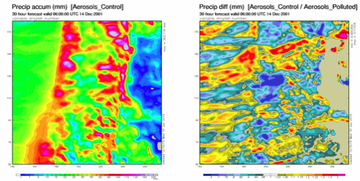
To see how the aerosols impact the precipitation as well as the cloud droplet concentration, a plot of the accumulated precipitation and ratio of Exp3 to Exp4 after 30 hours is provided in Fig. 5. The storm makes a massive amount of rain and snow, particularly where there are steep mountain slopes as expected. Furthermore, the differences in precipitation between the variable droplet experiments (3 and 4) are generally less than the differences (not shown) in the constant droplet number experiments (1 and 2). This is expected since the droplet concentrations in either Exp3 or Exp4 do not always remain as low or as high, respectively, as their counterparts in Exp1 and Exp2. Furthermore, the placements, amounts, and differences all lie within the range of results of Exp1 and Exp2, which are a good indication the code is working as intended.
Fig. 5 Total accumulated precipitation in Experiment 3 after 30 hours (left) and precipitation ratio Exp3/Exp4.

5.2 Ice nucleation evaluation

To test the new ice activation scheme, we selected a case study from the Ice in Clouds Experiment – Layer (ICE-L) field project since it offered good observational data. ICE-L focused on heterogeneous ice nucleation and attempted to separate different ice crystal formation mechanisms. The field campaign collected in situ measurements of layer/wave clouds in Wyoming and Colorado. The case study in this report occurred on 16 Nov 2007 when the NCAR C-130 aircraft sampled a wave cloud in southeastern WY at a temperature near -22°C. On the upwind side of the cloud amidst upward vertical velocity of 2 m/s, the aircraft probes measured a liquid water content of 0.15 g/m³ and hardly any ice. However, on the downwind portion of the cloud, they measured ice crystal concentration between 1 and 100 L⁻¹. The ice nuclei measurements indicated a maximum concentration of about 5 L⁻¹ and this discrepancy (compared to crystal concentration) is probably due to sampling of ice crystals that formed homogeneously at lower temperatures (higher altitude) that fell to the measurement level (Field et al, 2009).

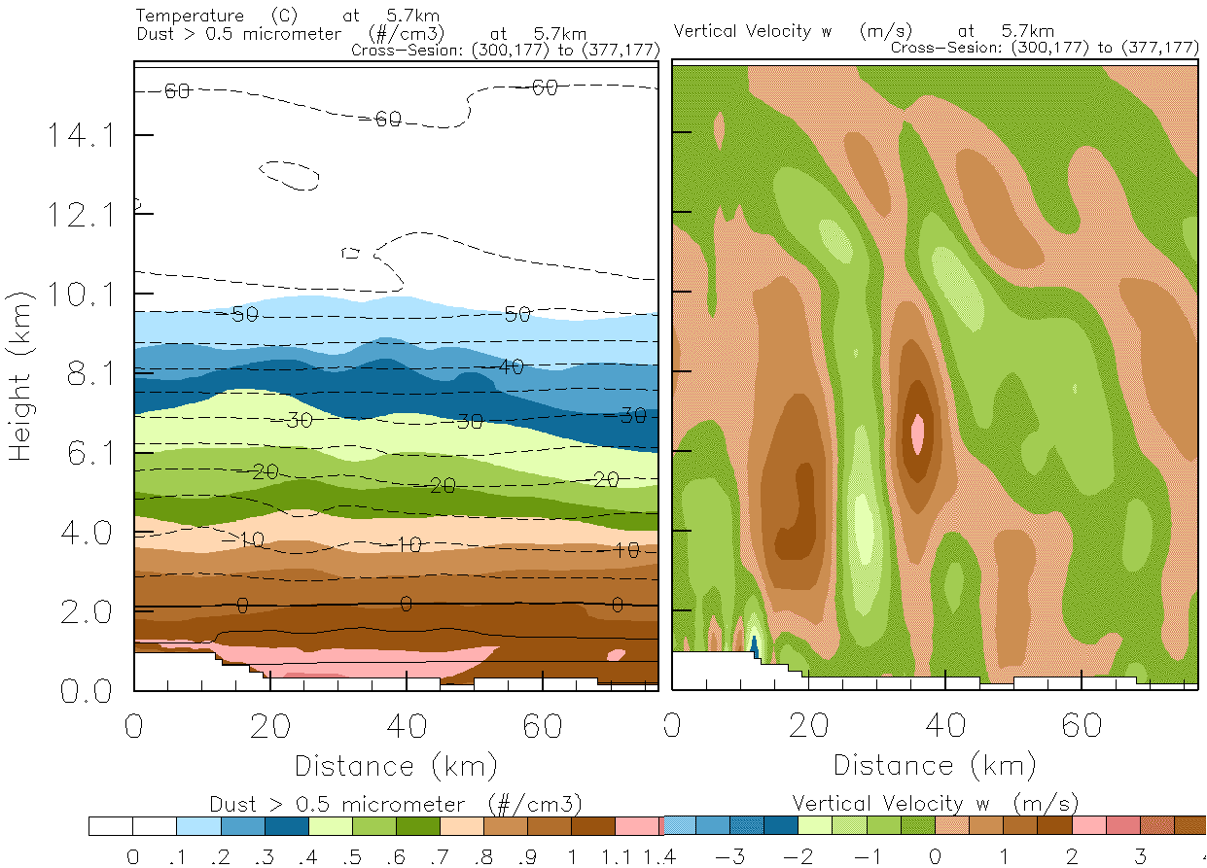
To simulate this case, the WRF model used three grids with spacing of 9, 3, and 1 km along with 85 vertical levels. Two test cases were run. In the first, the original, temperature-dependent ice nucleation parameterization was used whereas the second simulation used the new dust-dependent parameterization described earlier using the input dust concentration provided by the GOCART dust climatology. The left panel of Fig. 6 shows a cross section of the dust concentration where the wave cloud occurred. The average measured concentration of aerosols with sizes greater than 0.5 μm was about 0.3 cm⁻³, while the modeled concentration was between 0.4 and 0.5 cm⁻³. The simulated vertical velocities are shown in the right panel and compare favorably with the measurements.
Fig. 6 WRF-predicted dust concentration (left) and vertical velocity along a cross section where the wave cloud was sampled by the NCAR-C130 aircraft.

Results using the old and new ice nucleation schemes are presented in Fig. 7. When using the original ice nucleation (left panel), the ice concentration was directly linked to the temperature and relatively high ice concentrations were produced within the wave cloud near 6 km altitude. After switching on the new dust-dependent ice nucleation scheme, the same cloud (middle panel) has a significantly lower ice concentration (1-5 L⁻¹). Recall the observations found the higher amount that was also predicted by the original scheme, but this is an example of getting the right answer for the wrong reason as the simulation at this point in time does not reproduce the observed condition of higher altitude cloud ice falling downward into the lower cloud. However, if we look one hour further into the simulation (right panel), then we see that the newer scheme is capable of having a relatively low ice concentration cloud that begins to be affected by high concentration ice falling from above. This result is due to the relatively low IN availability in the new scheme as compared to a purely temperature-dependent ice initiation scheme.
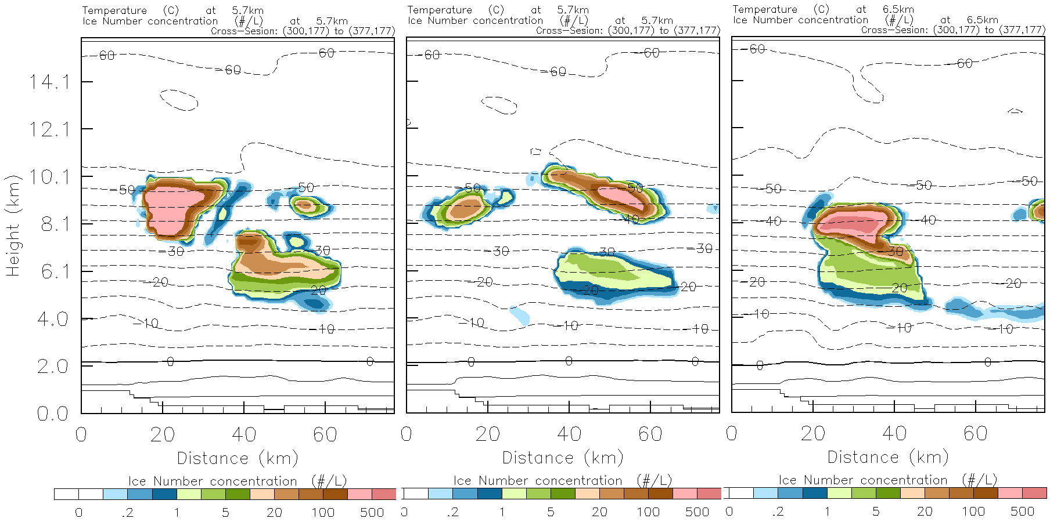
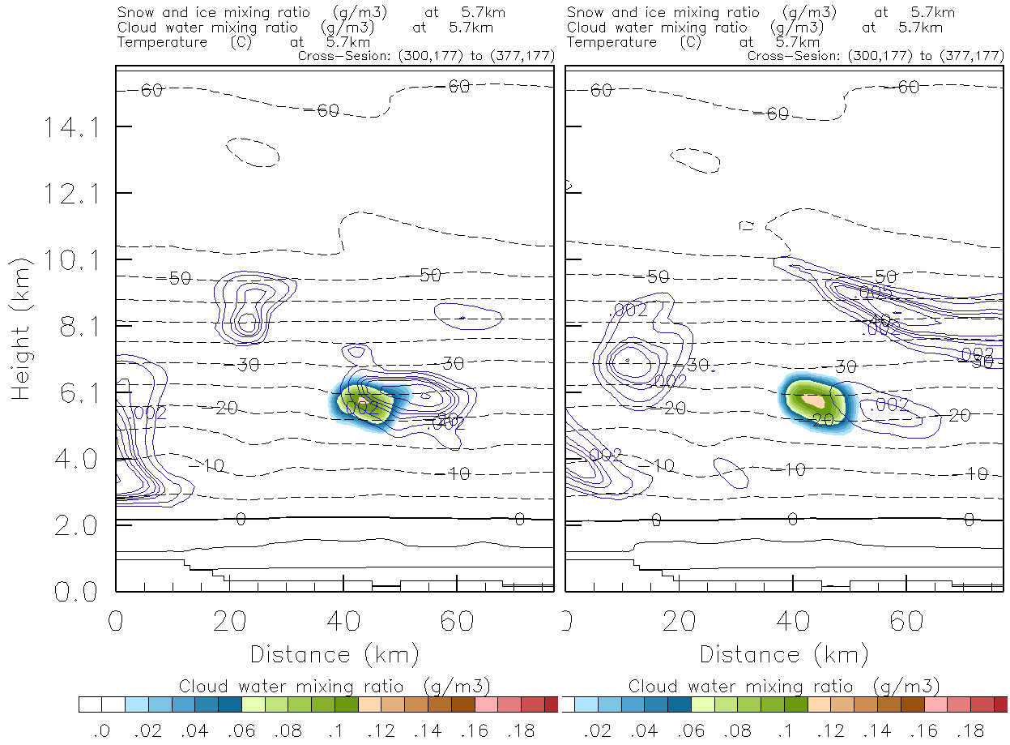
Fig. 7 WRF-predicted ice crystal concentration using the original scheme (left panel) and the new scheme (middle panel) at 1500 UTC 16 Nov 2007. An hour later, the new scheme properly captures the high ice concentrations falling into the lower cloud (right panel).

A side effect of the change in ice crystal concentration is the amount of supercooled liquid water, which directly affects the potential for aircraft icing. Shown in Fig. 8 is the simulated cloud water content in the same experiments. Note the slightly higher amount of supercooled water in the experiment with the new ice initiation. The reason for the change is that a larger number of ice crystals grow more efficiently by water vapor diffusion than fewer ice crystals as found in the new scheme. Therefore, under conditions of relatively few ice nuclei, the new scheme is more likely to contain higher liquid water contents than when using the old scheme. It is also possible that the opposite occurs under the condition of plentiful ice nuclei potentially caused by a major dust storm to supply plenty of nucleation sites for ice crystals. This is believed to mimic the real atmosphere much more than the typical temperature-dependent ice nucleation schemes of the past three decades.
Fig. 8 WRF-predicted cloud liquid water content using old ice scheme (left) and new scheme (right) at same time as Fig. 7a,b.

5.3 Dust emission and wet scavenging evaluation

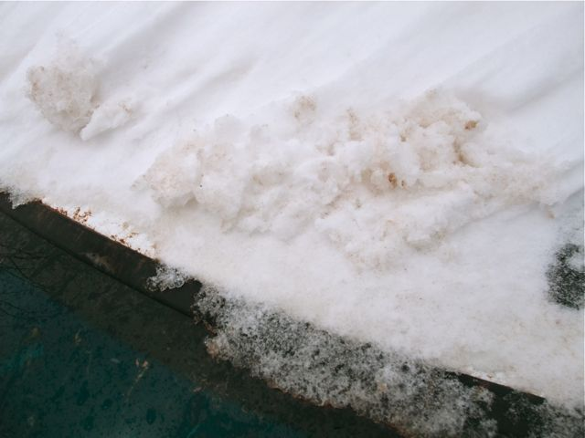
To test and evaluate the surface dust emission and wet deposition, we picked a recent event from 28-29 April 2010. In this event, a strong spring storm passed the Four Corners region and kicked up lots of red desert dust that combined with a late-season snowstorm passing through Colorado and neighboring states. The dust was clearly evident to most residents as the snow melted and left a red coating on everything outdoors. Figure 9 shows a picture taken in Summit County, Colorado of a car with the “dusty” snow
Fig. 9 "Dusty" snow on a car taken in Summit County, CO on 29 Apr (source: http://summitvoice.files.wordpress.com/2010/04/dust4.jpg)

While we do not have direct measurements of the amount of dust in this case, we strive to see if some basic aspects of dust emission, transport, and capture by precipitation appears to work properly. A preliminary WRF simulation of this event reveals encouraging results. A plot of the 18-hour forecast valid at 1800 UTC 29 Apr 2010 in the left panel of Fig. 10 shows the lowest model level dust number concentration. For comparison in the middle panel, the Navy Aerosol Analysis and Prediction System (NAAPS) subjectively confirms that the highest dust concentrations are found in the same general regions with a tendency to be elongated from the Four Corners region towards the northeast. However, a flaw in the dust emission scheme appears obvious near the CA-AZ border and the relatively tiny islands off Baja California as a clear streamer of dust is ejecting from the island.

To check the results of the wet deposition scheme, the location of precipitation should approximately coincide with a depletion of dust concentration. By comparing regions of local minima in dust concentration in the left panel of Fig. 10 to the 1-h precipitation in the right panel, we see the expected correlation. Locations where it is most obvious appear in north-central Colorado and western Montana. Subjectively it appears that primary fundamentals are implemented properly and more detailed testing, evaluation, and calibration is required in the future.

6. Summary

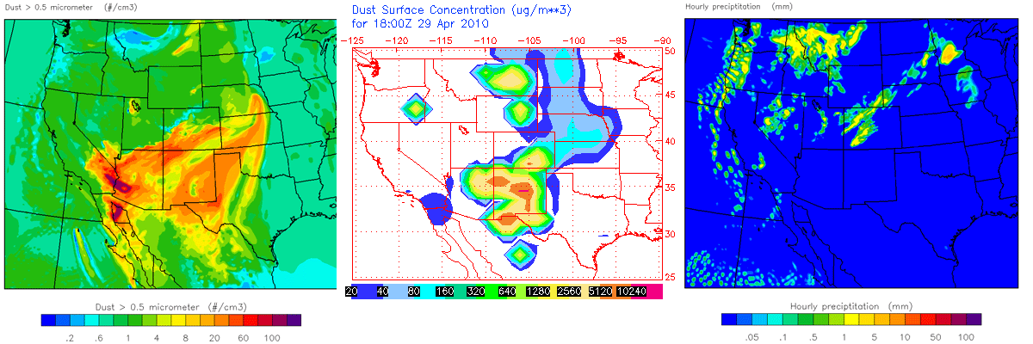
Preliminary tests of a modified version of the Thompson bulk microphysics scheme in WRF, which includes explicit treatment of aerosols to activate cloud droplets and ice crystals, show promising results. To activate cloud condensation nuclei, sulfate and sea salt aerosols were used from a global climatology dataset. To activate ice crystals, dust aerosols were used in place of the traditional temperature-dependent schemes and improvement compared to observations was noted. The new scheme was implemented with the fewest additional variables to consider computational cost, but it could be altered to include more sophisticated inputs of other aerosol species, which another chemistry or aerosol model may provide as input to the scheme. In the immediate future, the water and ice activation codes will be unified into the same code/version, as they are currently separate. Also, the process of falling precipitation that captures aerosols (scavenging) needs to be added. The surface dust emission also requires additional testing and tuning. Further into the future, the problem of turbulent motions at scales less than the grid spacing need to be considered, especially in terms of the activation of CCN, but also IN. Also, the scheme will need further modifications to be capable of inputting multiple aerosol species that can serve as CCN and be capable of directly linking with the WRF-Chem model. Lastly, the new scheme requires additional testing in idealized and real cases to find/correct deficiencies and improve forecasts, especially in the application of aircraft icing and surface precipitation type and amount.

Fig. 10 left) WRF-predicted dust concentration at lowest model level at 1800 UTC 29 Apr 2010, middle) Navy Aerosol Analysis and Prediction System (NAAPS) analysis of surface dust concentration, and right) 1-h precipitation forecast.

References:

Chin, M., T. Diehl, O. Dubovik, T. F. Eck, B. N. Holben, A. Sinyuk and D. G. Streets, 2009: Light absorption by pollution, dust, and biomass burning aerosols: a global model study and evaluation with AERONET measurements. Ann. Gephys, 27, 3439-3463.
DeMott P. J., A. J. Prenni, X. Liu, S. M. Kreidenweis, M. D. Petters, C. H. Twohy, M. S. Richardson, T. Eidhammer, and D. C .Rogers, 2010: Predicting global atmospheric ice nuclei distributions and their impacts on climate. PNAS, 107(25), doi:10.1073/pnas.0910818107.
Eidhammer, T., P. J. DeMott, and S. M. Kreidenweis, 2009: Comparison study of heterogeneous ice nucleation parameterization in a parcel model framework. J. Geophys. Res., 114, D06202, doi:10.1029/2008JD011095.
Feingold, G. and A. J. Heymsfield, 1992: Parameterizations of condensational growth of droplets for use in general circulation models. J. Atmos. Sci., 49, 2325-2342.
Field, P.R., A. J. Heymsfield, D. C. Rogers, J. Stith, P. DeMott, S. Haimov, S. J. Murphy, K. Pratt, C. Twohy, K. Prather, J. H. Seinfeld, B. J. Shipway, T. Eidhammer, and A.J. Prenni, 2010: Contrasting the ice nucleation in two lee wave clouds observed during the ICE-L campaign. J. Atmos. Sci, submitted.
Koop, T., B. P. Luo, A. Tsias, and T. Peter, 2000: Water activity as a determinant for homogeneous ice nucleation in aqueous solutions. Nature, 406, 611-614.
Thompson, G., P. R. Field, W. D. Hall, and R. M. Rasmussen, 2008: Explicit forecasts of winter precipitation using an improved bulk microphysics scheme. Part II: Implementation of a new snow parameterization. Mon. Wea. Rev., 136, 5095-5115.
Ward, D. S., T. Eidhammer, W. R. Cotton, and S. M. Kreidenweis, 2010: The role of particle size distribution in assessing aerosol composition effects on simulated droplet activation. Atmos. Chem. Phys., 10, 5435-5440.

